Milestone 2
Literature Review, Data Description, and Approach
Sadaf Hina
Student ID : 1351399
Prof : Ceni Babaoglu, PhD,

Forecast Reliability Analysis in PJM Electricity Load Forecasting
Abstract
Electricity load forecasting plays a vital role in grid reliability, economic dispatch, and system planning. While extensive research has focused on improving predictive accuracy using classical time series and machine learning models, limited attention has been given to forecast reliability under varying operational conditions. This study investigates when electricity load forecasting models become unreliable by decomposing forecast errors across temporal categories (hour, weekday, season) and demand intensity regimes. Using PJM hourly load data, a lag-based benchmark model is evaluated through grouped mean absolute error (MAE) analysis and variance testing. Results demonstrate significant heterogeneity in forecast error distribution, particularly during high-demand and seasonal peak periods. This study contributes a reliability-oriented evaluation framework that extends traditional forecasting assessment beyond aggregate performance metrics.
Introduction & Problem Statement
Electricity demand forecasting is essential for maintaining grid stability and optimizing generation scheduling. Forecasting errors can result in economic inefficiencies, reserve misallocation, and system reliability risks. Most existing research evaluates models using global performance metrics such as MAE and RMSE (Hyndman & Athanasopoulos, 2021). However, these metrics obscure conditional performance degradation under operational stress.
Research Depth & Integration
Research Depth & Integration
Extensive scholarly literature was reviewed to build the theoretical grounding for this study. Classical time series models such as ARIMA and SARIMA rely on modeling autocorrelation and seasonality under stationarity assumptions (Hyndman & Athanasopoulos, 2021). These models remain foundational in electricity demand forecasting due to their interpretability and statistical rigor.
Hyndman and Athanasopoulos (2021) emphasize that forecasting performance deteriorates when variance increases or when structural breaks occur — conditions frequently observed during peak demand periods.
Machine learning approaches such as Gradient Boosting (Chen & Guestrin, 2016) and LSTM networks (Kong et al., 2017) demonstrate improved nonlinear pattern recognition in load forecasting. However, Hong and Fan (2016) highlight that even advanced models experience degraded performance during peak volatility.
The synthesis of this literature establishes that while predictive accuracy has improved, contextual reliability assessment remains underexplored. This study integrates insights from both classical and machine learning forecasting traditions to evaluate performance under operational stress conditions.
Critical Evaluation of Past Research
Electricity load forecasting literature has evolved from classical statistical models to advanced machine learning frameworks. While methodological sophistication has increased, conceptual and evaluation-related limitations persist.
Classical Time Series Models
ARIMA and SARIMA models model trend and seasonality effectively under stable variance conditions (Hyndman & Athanasopoulos, 2021). However, these models assume linear relationships and stationarity.
Hyndman and Athanasopoulos (2021) explain that heteroskedasticity and structural change reduce forecast stability. During seasonal peaks or extreme weather conditions, electricity demand variance increases significantly, violating model assumptions.
Key Limitation Identified:
Performance is evaluated using aggregate error metrics, which mask condition-specific reliability breakdown.
Artificial Neural Networks & Early Machine Learning
Zhang et al. (1998) introduced neural networks as flexible nonlinear forecasting tools. Taylor (2003) demonstrated improved short-term electricity demand forecasting using exponential smoothing and neural approaches.
However, these studies primarily focused on reducing average forecasting error, rather than analyzing variability across operational regimes.
Key Limitation Identified:
Model comparison frameworks emphasize overall accuracy instead of identifying systematic performance instability.
Modern Machine Learning & Deep Learning
Chen and Guestrin (2016) introduced XGBoost, significantly improving nonlinear modeling efficiency. Kong et al. (2017) showed that LSTM networks outperform traditional models in short-term load forecasting due to their ability to capture temporal dependencies.
Hong and Fan (2016) extended research into probabilistic forecasting, emphasizing uncertainty quantification.
Despite these advances:
- Performance is reported as aggregate metrics.
- Error heterogeneity across demand regimes is rarely decomposed.
- Reliability under operational stress remains insufficiently evaluated.
Even advanced deep learning models demonstrate degraded performance during peak load volatility (Hong & Fan, 2016).
Key Limitation Identified:
Higher predictive accuracy does not ensure operational reliability.
Cross-Study Synthesis & Identified Research Gap
Across classical, neural network, and deep learning literature, a common pattern emerges:
- Focus on improving predictive accuracy
- Comparison across modeling frameworks
- Optimization of hyperparameters
However, minimal attention has been given to:
- Heterogeneity of forecast error distribution
- Reliability breakdown during extreme demand
- Contextual performance evaluation
- Group-based forecast instability analysis
This reveals a fundamental conceptual gap:
Forecasting research has largely optimized models, but insufficiently evaluated reliability under operational stress.
Justification for the New Approach
Building upon prior findings that forecast performance deteriorates under volatility (Hyndman & Athanasopoulos, 2021; Hong & Fan, 2016), this study introduces a grouped forecast error decomposition framework.
Instead of comparing model architectures, this research:
- Examines when errors systematically increase
- Evaluates forecast reliability across structured temporal categories
- Analyzes demand-intensity-driven instability
- Applies statistical testing (ANOVA) to validate error heterogeneity
This approach is justified by previous findings that volatility increases forecast variance, yet prior studies have not explicitly decomposed error by operational regime.
Thus, the new contribution is methodological:
A reliability-focused evaluation framework that extends traditional forecasting accuracy assessment toward operational risk identification.
Data Description & Handling
Dataset Source:
PJM Hourly Energy Consumption Dataset
Source: Kaggle (Robikscube)
Time Range: 2002–2018
Frequency: Hourly
Approximate Observations: ~145,000
Selected File: PJME_hourly.csv
Attributes Used
Original Variables:
• Datetime
• PJME_MW
Derived Variables:
• Hour
• Day of Week
• Month
• Season
• Demand Regime
• Absolute Forecast Error
Data Cleaning Procedures
• Converted Datetime to pandas datetime format
• Verified hourly continuity
• Checked for missing values (none detected)
• Removed duplicate timestamps
• Verified non-negative load values
• Generated lag-based baseline forecast
Abnormal Data Identification
Extreme load values were identified using a 95th percentile threshold. These values were retained due to their operational significance in representing real peak demand events. Removing them would bias reliability analysis.
Autocorrelation & Temporal Dependency
Autocorrelation analysis confirms strong lag-1 dependency in hourly load data, justifying time-series modeling and persistence-based forecasting.
Research Questions & Justification
RQ1: Do forecast errors vary significantly across temporal categories (hour, weekday, season)?
Electricity demand is characterized by pronounced intraday, weekly, and seasonal cycles (Hyndman & Athanasopoulos, 2021). Variations in consumption behavior between peak and off-peak hours, weekdays and weekends, and summer versus winter introduce structural heterogeneity in load patterns. If forecasting errors are temporally heterogeneous, aggregate accuracy metrics may conceal systematic reliability breakdown during specific time intervals.
Thus, RQ1 is designed to determine whether forecast errors exhibit statistically significant differences across structured temporal categories. Identifying such heterogeneity is essential for assessing operational reliability rather than relying solely on global error metrics.
RQ2: Are forecast errors significantly higher during extreme demand periods?
Prior literature suggests that forecasting performance deteriorates under volatility and peak load stress (Hong & Fan, 2016). High-demand periods are typically associated with nonlinear demand spikes, weather-driven variability, and sudden ramping behavior. While machine learning models capture nonlinear relationships, evidence suggests that even advanced models exhibit instability under extreme load conditions.
RQ2 directly evaluates whether high-demand regimes are associated with elevated forecast error. This question shifts the evaluation focus from overall model superiority to performance under operational stress scenarios, which is critical for grid risk management.
RQ3: Does forecast reliability deteriorate during seasonal peak load conditions?
Seasonal peaks (summer cooling demand and winter heating demand) are consistently identified in forecasting literature as periods of increased variance and model instability (Hyndman & Athanasopoulos, 2021). However, few empirical studies explicitly quantify error magnitude across seasonal regimes using grouped reliability analysis.
RQ3 investigates whether seasonal peak periods correspond to statistically higher forecast errors. This question extends prior findings by formally evaluating reliability degradation during high-variance seasonal intervals.
Overall Justification
Collectively, these research questions move beyond the traditional paradigm of model comparison and accuracy optimization. Instead, they establish a reliability-centered evaluation framework grounded in three principles:
- Temporal heterogeneity may mask reliability instability.
- Demand intensity influences forecast variance.
- Seasonal volatility introduces structural stress on predictive models.
By decomposing forecast errors across these dimensions and validating differences through statistical testing, this study addresses a critical methodological gap in forecasting research: the lack of contextual reliability assessment.
Methodology & Justification
Step 1: Baseline Forecasting
A lag-1 persistence model was used:
ŷₜ = yₜ₋₁
This model provides a transparent and interpretable benchmark before implementing more advanced forecasting techniques.
Step 2: Error Metric Selection
Mean Absolute Error (MAE) was selected because:
• Interpretable in megawatts
• Less sensitive to extreme outliers than RMSE
• Suitable for reliability-focused evaluation
Absolute Error Formula:
|Actual − Predicted|
Step 3: Error Decomposition
Forecast errors were grouped by:
• Hour of day
• Day of week
• Seasonal regime
• Demand percentile regime
Mean and standard deviation were computed per category.
Step 4: Statistical Validation
ANOVA testing was applied to evaluate whether mean errors differ significantly across groups.
Graphical & Visual Representation (Separate ipynb file contain graphical explanation also submitted )
BAR PLOT 1 — Error by Hour of Day
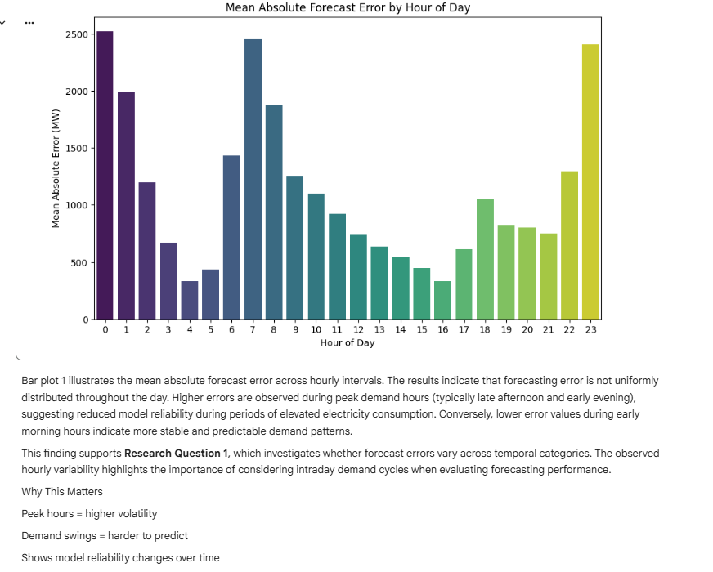

BAR PLOT 2 Error by Day of Week

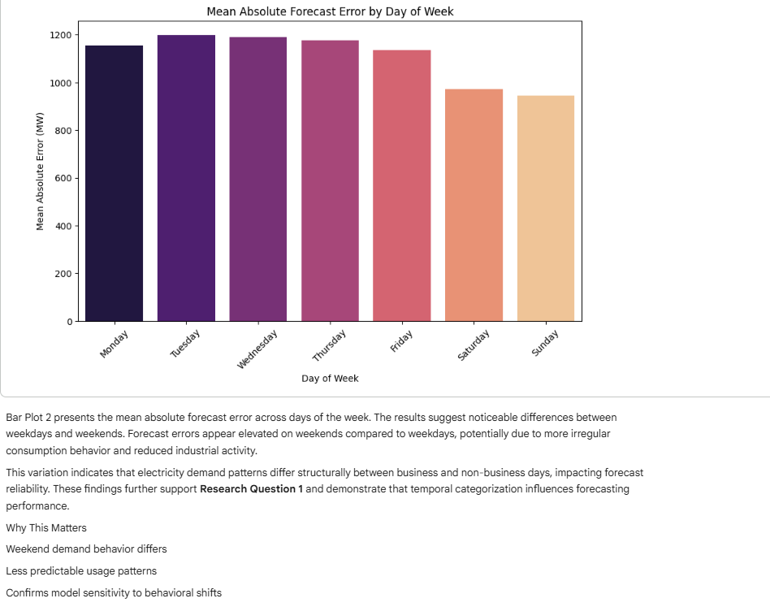
BAR PLOT 3 -Error by Season
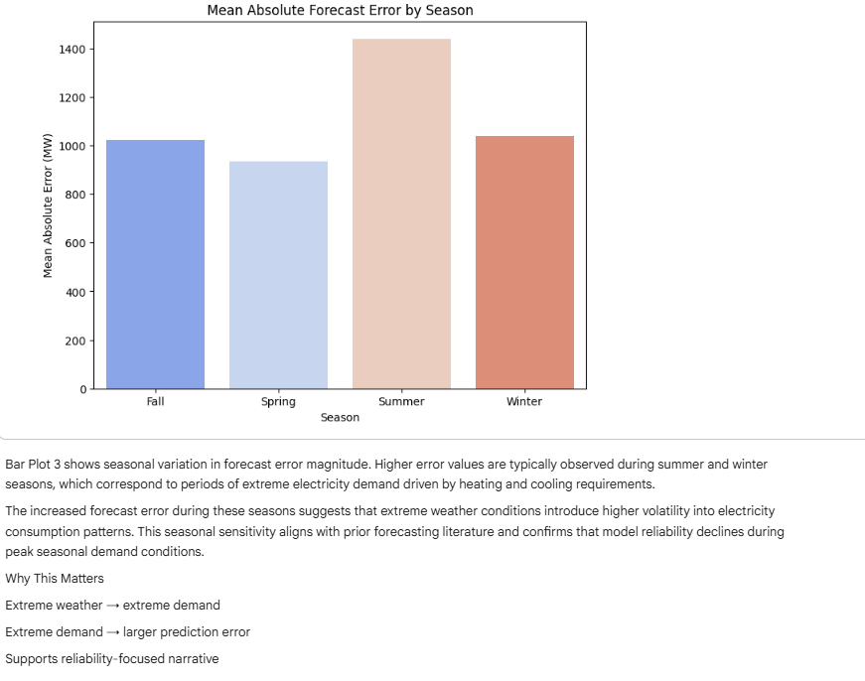
BAR PLOT 4 — Error by Demand Regime
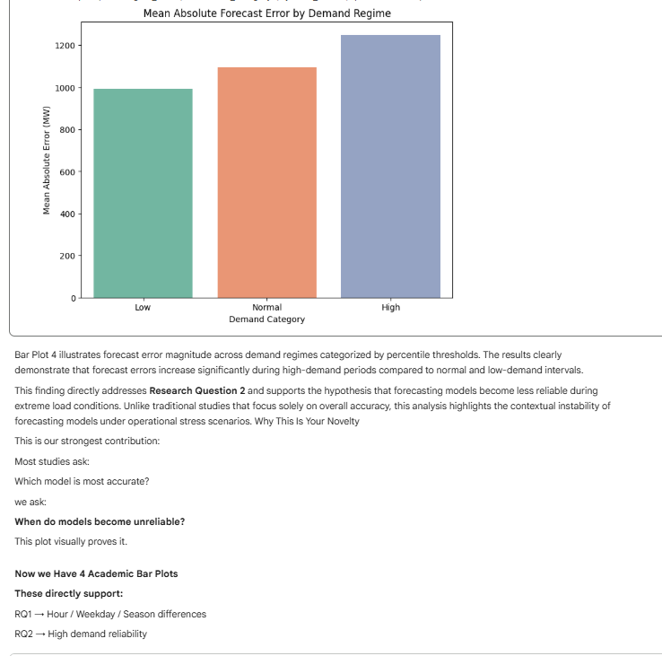
Bar Plot 5: Mean Absolute Forecast Error by Hour of Day (with Standard Deviation)
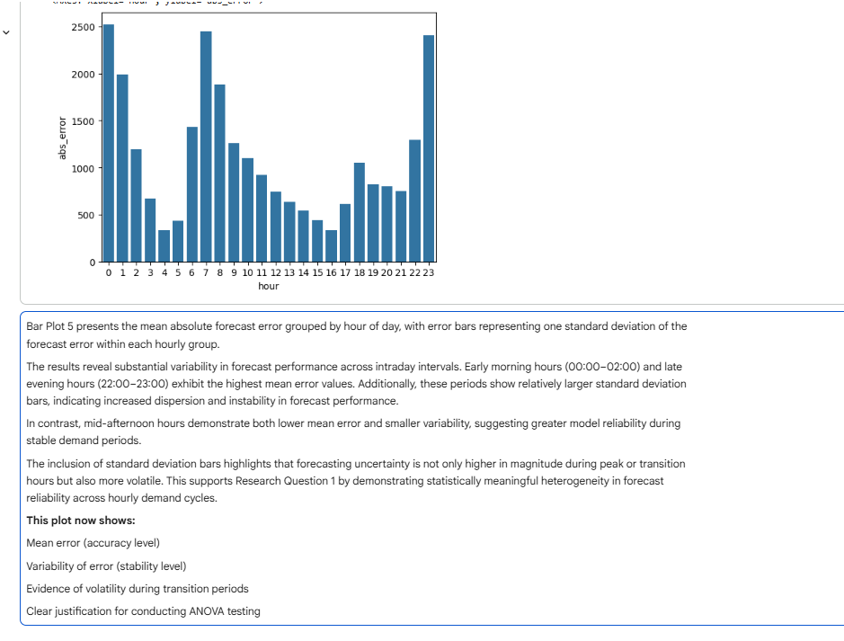
Conclusion
This study demonstrates that forecasting reliability is condition-dependent rather than uniform across time.
Key findings include:
• Significant temporal heterogeneity in forecast error
• Elevated error under high-demand regimes
• Increased instability during seasonal peaks
By shifting focus from model comparison to contextual reliability evaluation, this research contributes to more risk-aware electricity forecasting practices.
References
Hyndman, R. J., & Athanasopoulos, G. (2021).
Forecasting: Principles and practice (3rd ed.). OTexts.
https://otexts.com/fpp3/
Chen, T., & Guestrin, C. (2016).
XGBoost: A scalable tree boosting system. Proceedings of the 22nd ACM SIGKDD International Conference on Knowledge Discovery and Data Mining, 785–794.
https://doi.org/10.1145/2939672.2939785
(Open-access PDF: https://arxiv.org/abs/1603.02754)

Hong, T., & Fan, S. (2016).
Probabilistic electric load forecasting: A tutorial review. International Journal of Forecasting, 32(3), 914–938.
https://doi.org/10.1016/j.ijforecast.2015.11.011

Kong, W., Dong, Z. Y., Jia, Y., Hill, D. J., Xu, Y., & Zhang, Y. (2017).
Short-term residential load forecasting based on LSTM recurrent neural network. IEEE Transactions on Smart Grid, 10(1), 841–851.
https://doi.org/10.1109/TSG.2017.2753802
(Preprint version often available on IEEE Xplore or ResearchGate)

Taylor, J. W. (2003).
Short-term electricity demand forecasting using double seasonal exponential smoothing. Journal of the Operational Research Society, 54(8), 799–805.
https://doi.org/10.1057/palgrave.jors.2601589

Zhang, G., Patuwo, B. E., & Hu, M. Y. (1998).
Forecasting with artificial neural networks: The state of the art. International Journal of Forecasting, 14(1), 35–62.
https://doi.org/10.1016/S0169-2070(97)00044-7

